Target Takes on Victoria’s Secret

The retailer is set to launch lingerie and sleepwear brands next month, challenging Amazon and other giants
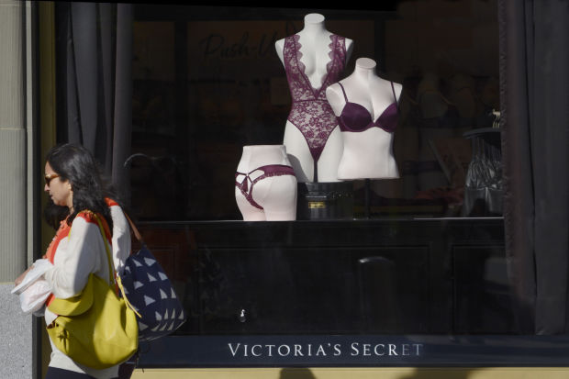
Victoria’s Secret accounts for about a quarter of the U.S. market for women’s underwear, more than four times the share of the No. 2 competitor. Photo: Robert Alexander/Getty Images

By
Khadeeja Safdar
Feb. 24, 2019 9:02 a.m. ET , WSJ
Target Corp. TGT -0.52% is launching new lines of lingerie and sleepwear, becoming the latest retail behemoth to challenge market leader Victoria’s Secret.
Victoria’s Secret has long dominated the intimates market with images of supermodels in push-up bras listed at prices up to about $60, but a shift in consumer preferences toward more natural looks and less structured garments—such as sports bras and bralettes—has made it easier for apparel retailers and online sellers to compete.
Target next month will launch three brands to sell women’s bras, underwear and pajamas that it expects will hit more than $1 billion in sales in a year. Some of the sales will come from eliminating Gilligan & O’Malley, its existing brand for undergarments and sleepwear. Target said all the new bras will cost less than $22 and include plus sizes. Amazon.com Inc., which in 2017 launched its own line of lingerie called Mae, sells private-label bras at prices mostly between $10 and $22.
Victoria’s Secret is also facing competition at the higher end of the market, where upstarts powered by social media and e-commerce, including ThirdLove and Lively, have been pitching themselves as more natural or inclusive alternatives.
Sales at American Eagle Outfitters Inc.’s lingerie brand, Aerie, have soared since the teen retailer stopped airbrushing its ads and began featuring models in various shapes. Adore Me, which began as an e-commerce startup but lately has been opening stores near Victoria’s Secret locations, said about a third of its revenue comes from plus sizes.
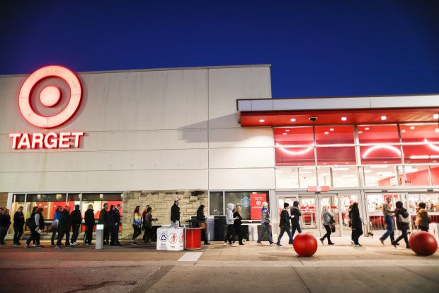
Target in March plans to launch three brands to sell women’s bras, underwear and pajamas. Photo: John Minchillo/Associated Press
Popular bra styles are now often without an underwire, or the metal strip used to create structured or push-up bras. According to data from NPD Group, sales of wirefree bras grew 10% in 2018, while underwire bra sales declined 8%. The market-research firm also said in-store sales of intimate apparel declined by 3% last year, while online sales grew by 7%.
Victoria’s Secret has tried to adjust by selling more sports bras and styles emphasizing comfort, but the brand has been resorting to markdowns to drive traffic to its stores and website. The company recently replaced its lingerie chief executive, brought back catalog mailings and teased a new swimwear collection after deciding to eliminate the category more than two years ago.
In an effort to win over new lingerie customers, Target said it would launch a marketing campaign featuring women with different bodies, ages and ethnicities. The company said it is also avoiding airbrushed images, as it has previously done with its swimwear advertising.
Target said more than 40% of its new bras will be wirefree and it plans to create dedicated sections on its website and in stores for the new brands. The website will also feature a tool to help women find their fits for bras. In the past three years, the company has launched 25 private-label brands and some clothing labels have exceeded more than $1 billion in sales during their first year.
“The timing is right,” said Mark Tritton, Target’s chief merchandising officer. “Consumer preferences in these categories have evolved, the industry has changed and we’ve created a lot of momentum in our broader apparel business.”
Target’s new intimates labels appear to match the brand strategy used by Victoria’s Secret parent L Brands Inc. LB -4.60% Target’s new lingerie line Auden is aimed at women who shop at Victoria’s Secret. Its loungewear brand Colsie is directed at shoppers of PINK, L Brands’ lingerie label for younger women. The company is also launching another sleepwear brand called Stars Above.
Target’s marketing and store displays have allowed it to launch more successful clothing brands than Amazon, which has been listing dozens of private-label brands online, said Juozas Kaziukėnas, founder of Marketplace Pulse, a business-intelligence firm focused on e-commerce. “Amazon’s strategy has worked for cheap generic items like batteries, but not for something as intimate as lingerie,” he said. Amazon declined to comment.
Comparable sales at Victoria’s Secret, which include digital and same-store sales, fell 3% in the fourth quarter and declined 2% in 2018. The company also said it plans to cut its annual dividend in half, starting with the March payout.
Meanwhile, the lingerie retailer remains married to its traditional marketing. Last year in a Vogue interview, Ed Razek, the longtime chief marketing officer of L Brands, said he doesn’t think the Victoria’s Secret fashion show should include transgender models, prompting backlash on social media from customers and celebrities. He later issued an apology. TV viewership of the fashion show has plummeted in recent years.
Victoria’s Secret still accounts for about a quarter of the U.S. market for women’s underwear, more than four times the share of the No. 2 competitor, according to Euromonitor.
“If you ask anyone, Victoria’s Secret is dead and their marketing is a relic of the past, but they are selling plenty of bras using the same marketing that everyone finds so distasteful,“ said Simeon Siegel, a Nomura Instinet analyst who covers the retail sector. ”At over $3 billion in lingerie sales, someone is still buying the product.”
Write to Khadeeja Safdar at khadeeja.safdar@wsj.com

